# Scenario 1 - Committing Files

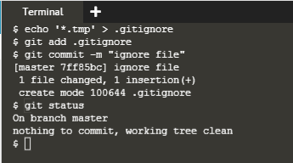

# Scenario 2 - Committing Changes

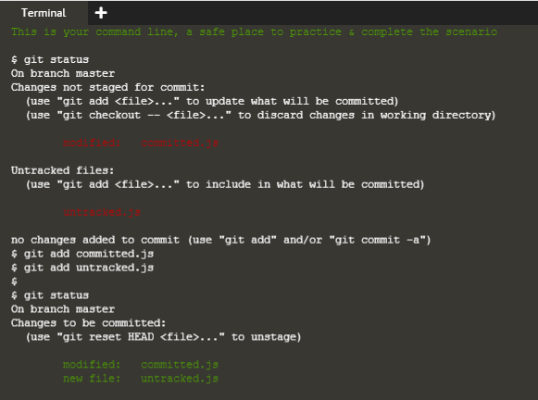

# Scenario 3 - Working Remotely

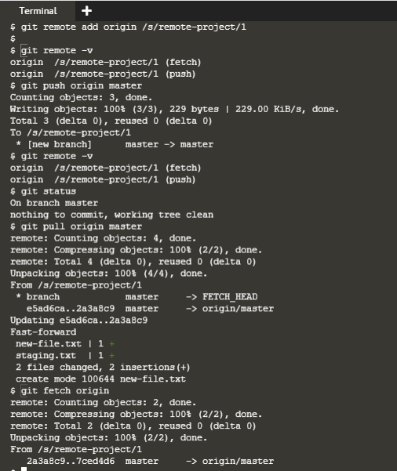

# Scenario 4 - Undoing Changes

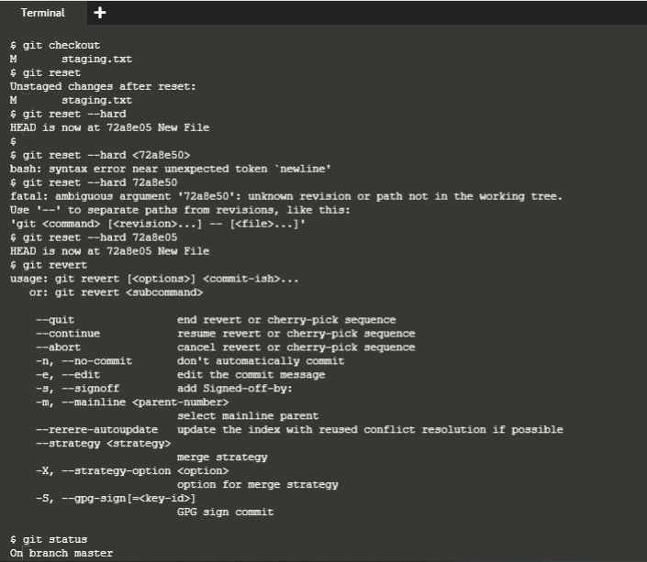

# Scenario 5 - Fixing Merge Conflicts

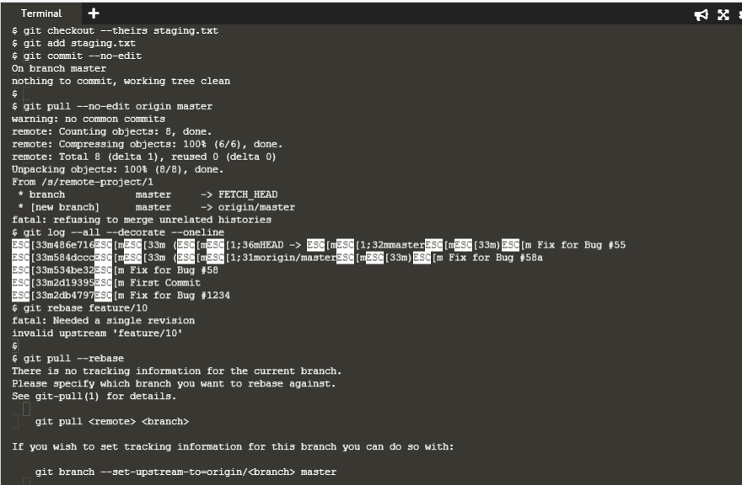

# Scenario 6 - Experiments Using Branches

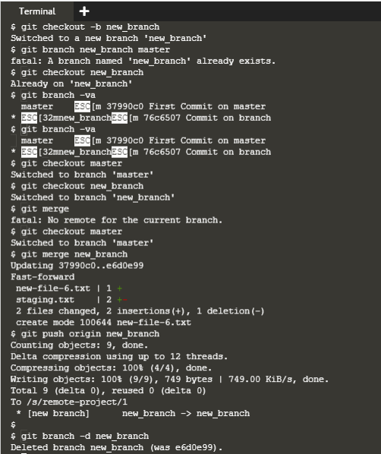

# Scenario 7 - Finding Bugs

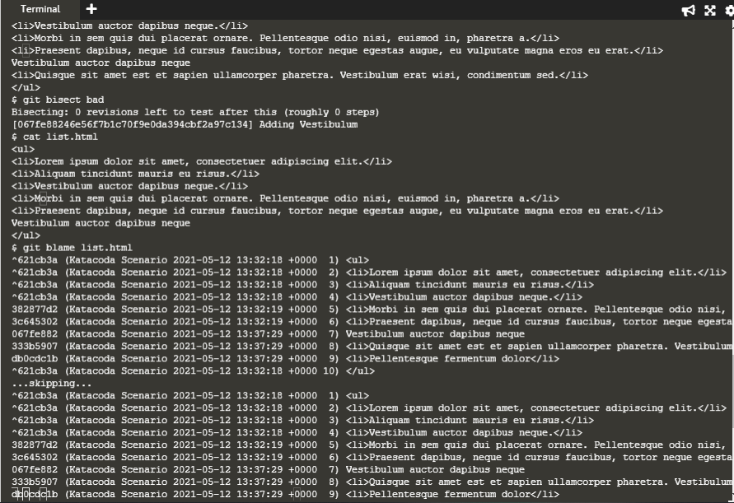

# Scenario 8 - Being Picky With Git

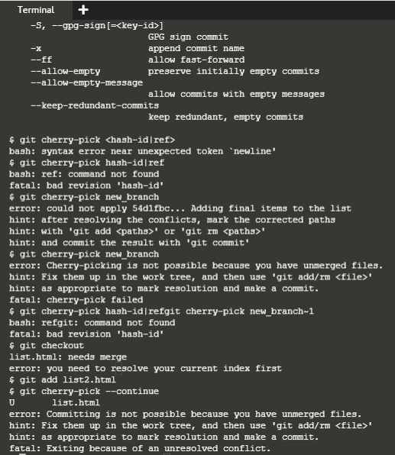

# Scenario 9 - Re-writing History

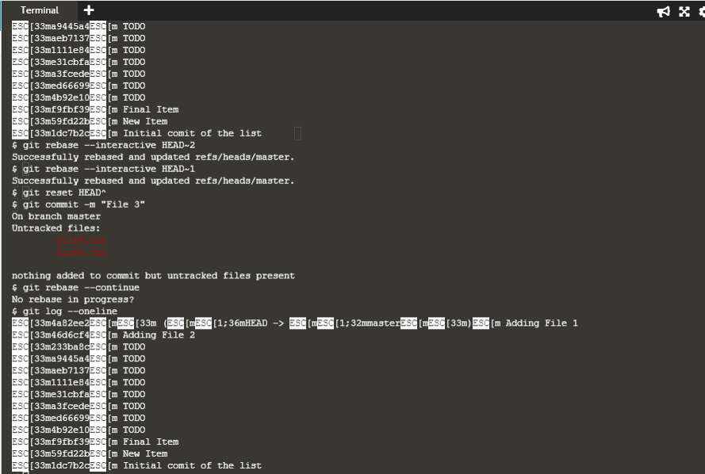

Pass practical scenario <https://www.katacoda.com/aossama/scenarios/git-scm-lab-101>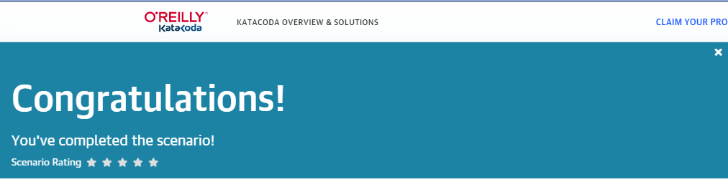

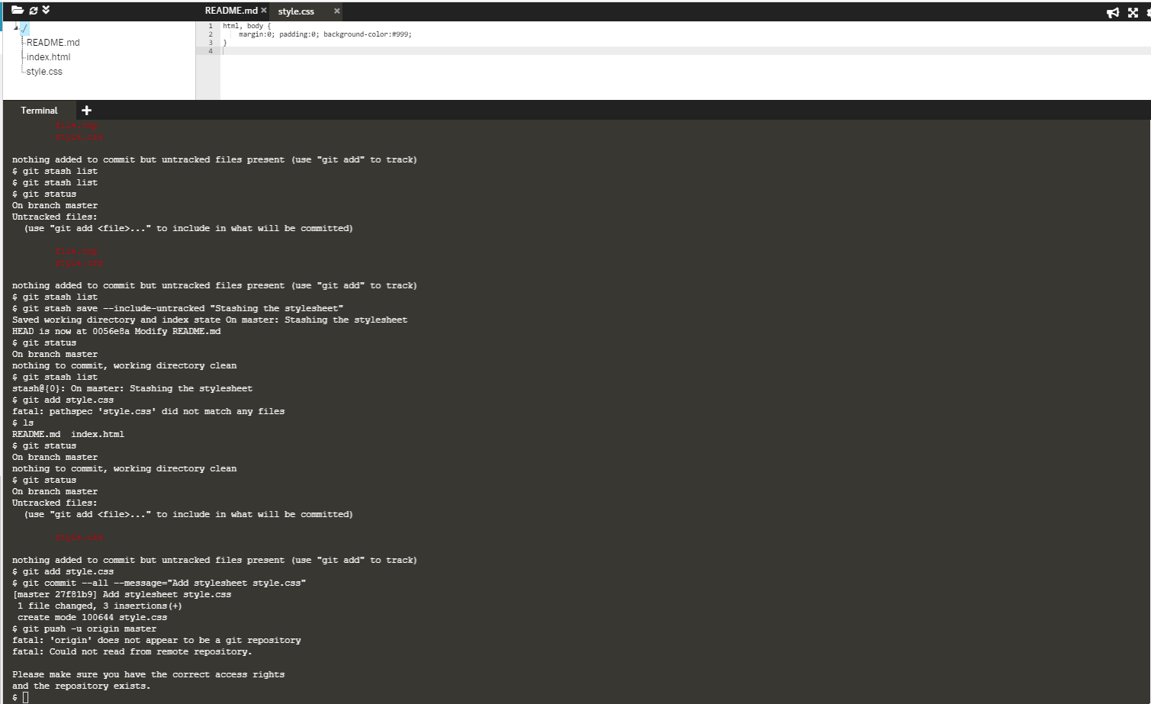

Pass practical scenario <https://www.katacoda.com/aossama/scenarios/git-scm-lab-102>

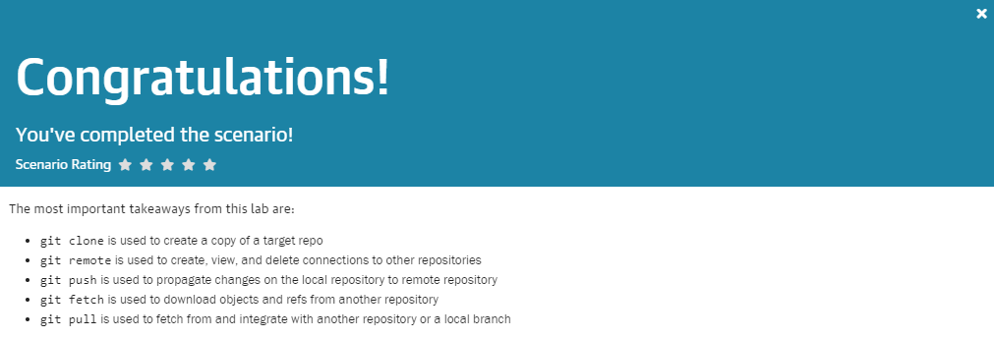

Pass practical scenario <https://www.katacoda.com/aossama/scenarios/git-scm-lab-201>

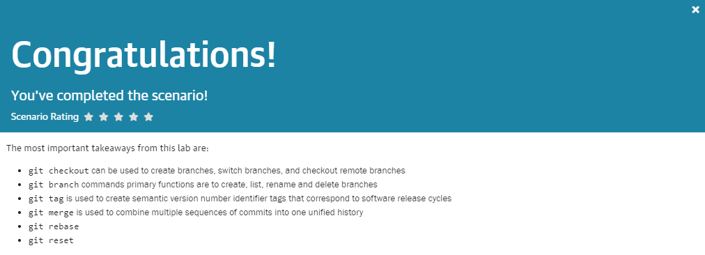

Pass practical scenario <https://www.katacoda.com/aossama/scenarios/git-scm-lab-202>

